DSA0501 – QUERY PROCESSING
LAB EXPERIMENTS
NAME : R.SABARISH
REG NO : 192324092
QUESTION 1:
import pandas as pd
from google.colab import files
uploaded = files.upload()
df = pd.read_csv("departments.csv")
print("Distinct Department IDs:")
print(df["DEPARTMENT_ID"].unique())
OUTPUT : 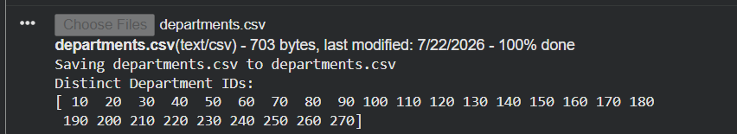

QUESTION 2:
import pandas as pd
from google.colab import files
uploaded = files.upload()
df = pd.read_csv("job_history.csv")
result = df.groupby("EMPLOYEE_ID").size()
result = result[result >= 2]
print("Employee IDs with two or more jobs:")
print(result.index.tolist())
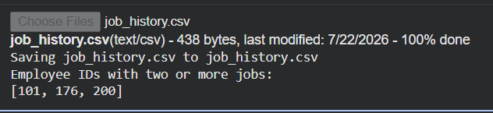
QUESTION 3:
import pandas as pd
from google.colab import files
uploaded = files.upload()
df = pd.read_csv("jobs.csv")
result = df.sort_values(by="JOB_TITLE", ascending=False)
print(result)
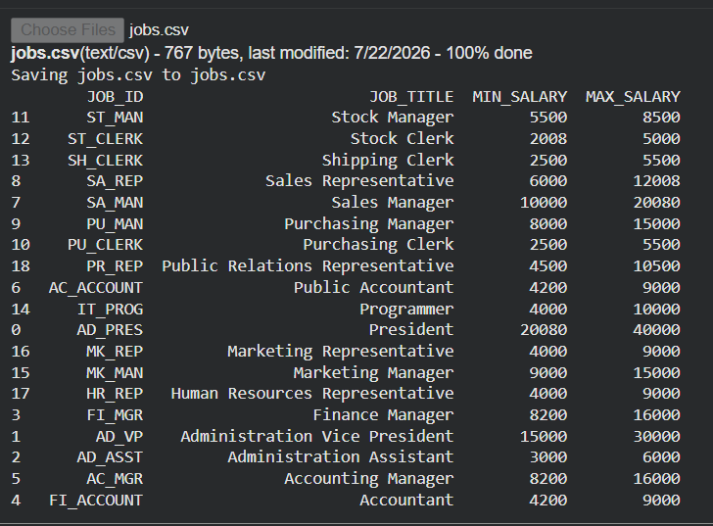
QUESTION 4 ;
import pandas as pd
import matplotlib.pyplot as plt
from google.colab import files
uploaded = files.upload()
df = pd.read_csv("alphabet_stock_data.csv")
df["Date"] = pd.to_datetime(df["Date"])
start_date = input("Enter Start Date (YYYY-MM-DD): ")
end_date = input("Enter End Date (YYYY-MM-DD): ")
filtered = df[(df["Date"] >= start_date) & (df["Date"] <= end_date)]
plt.figure(figsize=(10,5))
plt.plot(filtered["Date"], filtered["Close"], marker="o")
plt.title("Alphabet Inc. Stock Price")
plt.xlabel("Date")
plt.ylabel("Closing Price")
plt.grid(True)
plt.show()
OUTPUT:
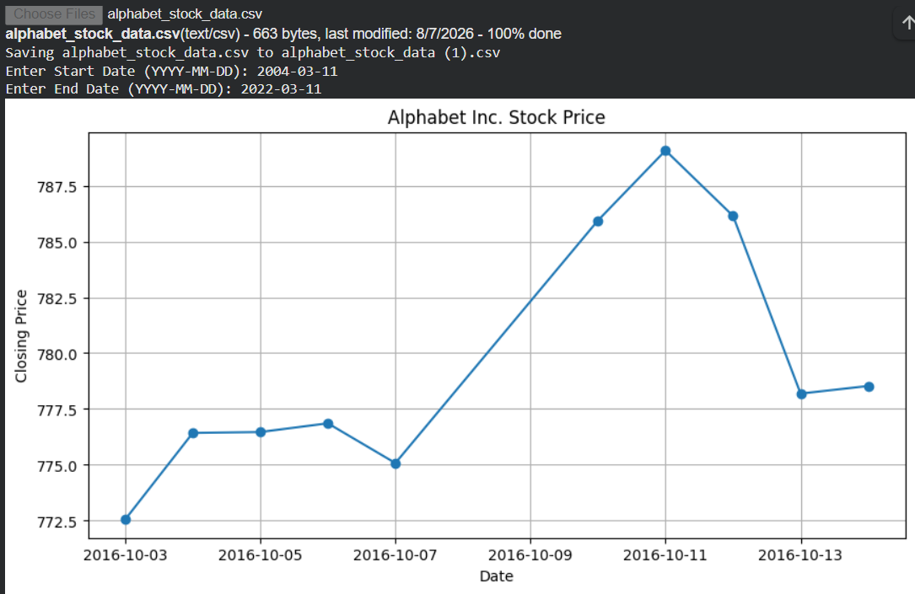
QUESTION 5:
import pandas as pd
import matplotlib.pyplot as plt
from google.colab import files
uploaded = files.upload()
df = pd.read_csv("alphabet_stock_data.csv")
df["Date"] = pd.to_datetime(df["Date"])
start_date = input("Enter Start Date (YYYY-MM-DD): ")
end_date = input("Enter End Date (YYYY-MM-DD): ")
filtered = df[(df["Date"] >= start_date) & (df["Date"] <= end_date)]
plt.figure(figsize=(10,5))
plt.bar(filtered["Date"], filtered["Volume"])
plt.title("Trading Volume")
plt.xlabel("Date")
plt.ylabel("Volume")
plt.xticks(rotation=45)
plt.show()
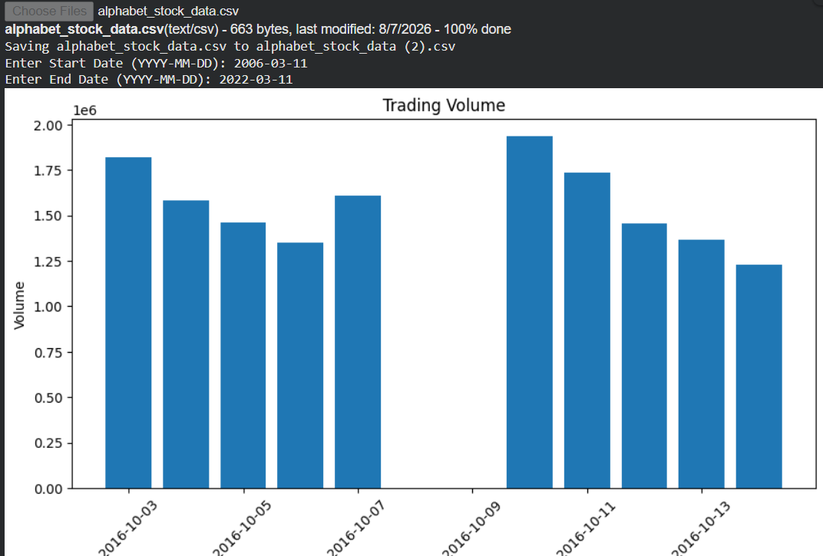

QUESTION 6:
import pandas as pd
import matplotlib.pyplot as plt
from google.colab import files
uploaded = files.upload()
df = pd.read_csv("alphabet_stock_data.csv")
plt.figure(figsize=(8,5))
plt.scatter(df["Volume"], df["Close"])
plt.title("Trading Volume vs Closing Price")
plt.xlabel("Volume")
plt.ylabel("Closing Price")
plt.grid(True)
plt.show()
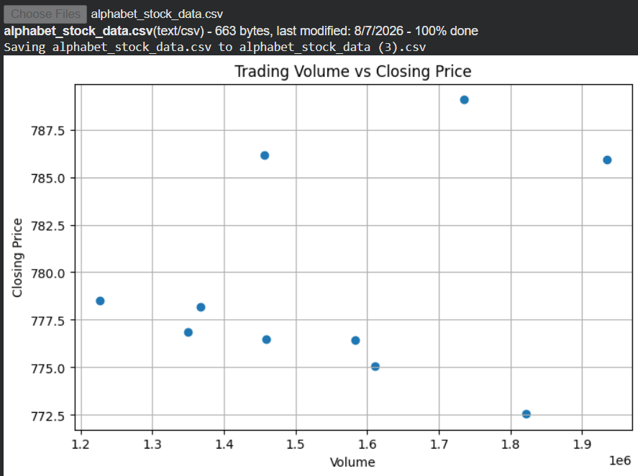
QUESTION 7:
import pandas as pd
from google.colab import files
uploaded = files.upload()
df = pd.read_csv("sales_data.csv")
pivot = pd.pivot_table(
df,
values="Sale_amt",
index="Item",
aggfunc=["max", "min"]
)
print(pivot)
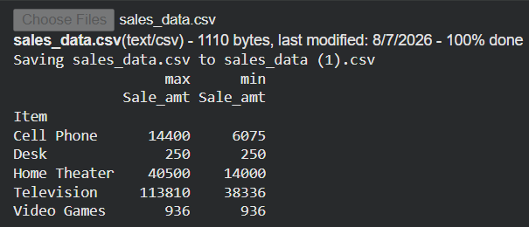
QUESTION 8;
import pandas as pd
from google.colab import files
uploaded = files.upload()
df = pd.read_csv("sales_data.csv")
pivot = pd.pivot_table(
df,
values="Units",
index="Item",
aggfunc="sum"
)
print(pivot)
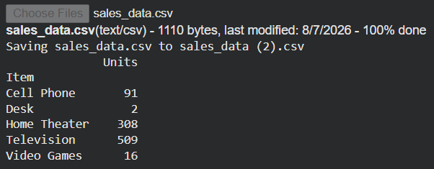
QUESTION 9 :
import pandas as pd
from google.colab import files
uploaded = files.upload()
df = pd.read_csv("sales_data.csv")
pivot = pd.pivot_table(
df,
values="Sale_amt",
index=["Region", "Manager", "SalesMan"],
aggfunc="sum"
)
print(pivot)
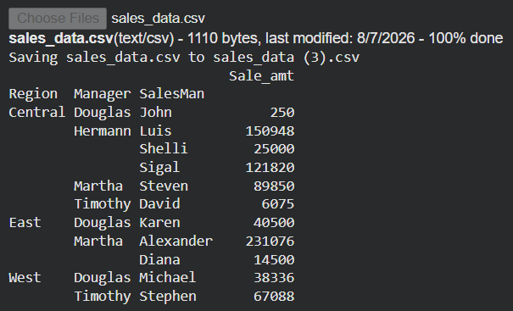
QUESTION 10 :
import pandas as pd
import numpy as np
df = pd.DataFrame(
np.random.randint(-100, 100, size=(10,4)),
columns=["A","B","C","D"]
)
def color_negative(val):
if val < 0:
return "color:red"
else:
return "color:black"
df.style.map(color_negative)
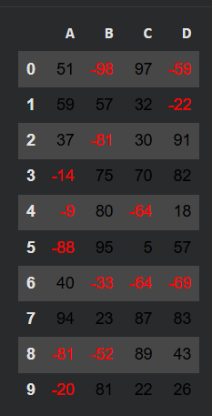
QUESTION 11 :
import pandas as pd
import numpy as np
df = pd.DataFrame(np.random.randint(1,100,size=(10,4)),
columns=["A","B","C","D"])
df.iloc[1,2] = np.nan
df.iloc[3,1] = np.nan
df.iloc[5,0] = np.nan
df.iloc[7,3] = np.nan
def highlight_nan(value):
if pd.isna(value):
return "background-color:yellow"
return ""
df.style.map(highlight_nan)
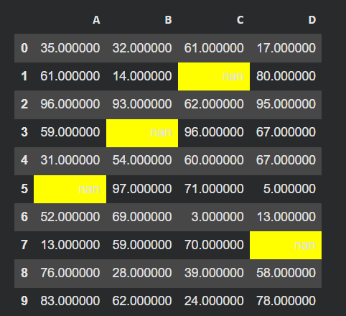
QUESTION 12:
import pandas as pd
import numpy as np
df = pd.DataFrame(np.random.randint(1,100,size=(10,4)),
columns=["A","B","C","D"])
df.style.set_properties(**{
"background-color":"black",
"color":"yellow"
})
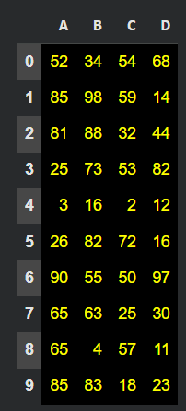
QUESTION 13:
import pandas as pd
import numpy as np
data = {
"A":[10,20,np.nan,40],
"B":[5,np.nan,15,25],
"C":[1,2,3,np.nan]
}
df = pd.DataFrame(data)
print("Original DataFrame")
print(df)
print("\nMissing Values (True/False)")
print(df.isnull())
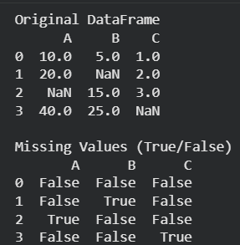
QUESTION 14:
import pandas as pd
import numpy as np
data = {
"A":[10,20,np.nan,40],
"B":[5,np.nan,15,25],
"C":[1,2,3,np.nan]
}
df = pd.DataFrame(data)
print("Original DataFrame")
print(df)
df.fillna(0, inplace=True)
print("\nAfter Replacing Missing Values")
print(df)
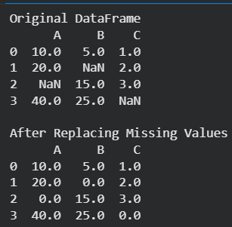
QUESTION 15:
import pandas as pd
import numpy as np
data = {
"A":[10,np.nan,np.nan,40],
"B":[5,np.nan,15,np.nan],
"C":[1,np.nan,np.nan,np.nan]
}
df = pd.DataFrame(data)
print("Original DataFrame")
print(df)
result = df[df.isnull().sum(axis=1) >= 2]
print("\nRows with at least 2 NaN values")
print(result)
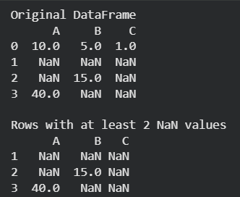
QUESTION 16:
import pandas as pd
from google.colab import files
uploaded = files.upload()
df = pd.read_csv("school_data.csv")
group = df.groupby("school_code")
print("Type of GroupBy Object:")
print(type(group))
for name, data in group:
print("\nSchool Code:", name)
print(data)
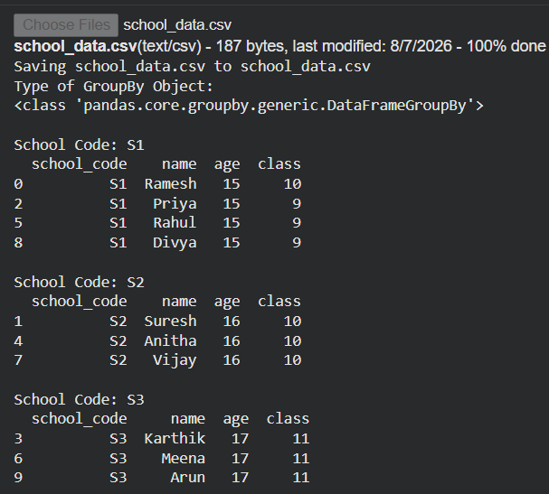
QUESTION 17:
import pandas as pd
from google.colab import files
uploaded = files.upload()
df = pd.read_csv("school_data.csv")
result = df.groupby("school_code")["age"].agg(["mean","min","max"])
print(result)
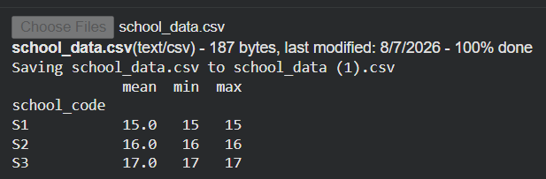
QUESTION 18 :
import pandas as pd
from google.colab import files
uploaded = files.upload()
df = pd.read_csv("school_data.csv")
group = df.groupby(["school_code","class"])
for name, data in group:
print("\nGroup:", name)
print(data)
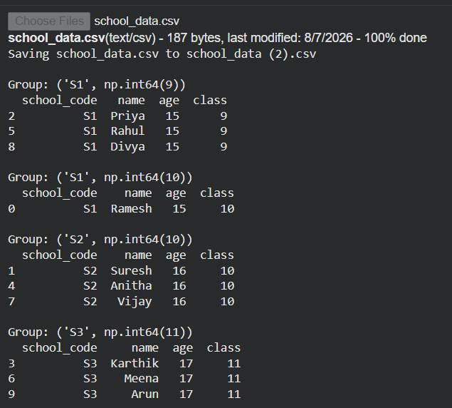
QUESTION 19:
import pandas as pd
from google.colab import files
uploaded = files.upload()
df = pd.read_csv("world_alcohol.csv")
print("Shape of Dataset:")
print(df.shape)
print("\nColumn Names:")
print(df.columns)
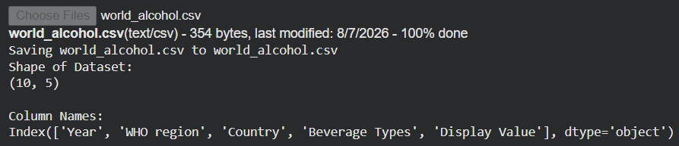
QUESTION 20 :
import pandas as pd
from google.colab import files
uploaded = files.upload()
df = pd.read_csv("world_alcohol.csv")
substring = input("Enter Country Name: ")
result = df[df["Country"].str.contains(substring, case=False, na=False)]
print(result.index)
